Timothy Nguyen,Dylan Monroe, Lee-Martin Clarke, Joshua Sim, Qifan Guo September 1, 2017

[cSC 4350] | [Fall 2017]
Zodiac

Resume of Each Group Member:
Timothy Nguyen
3609 PostWaite Cir NW, Duluth, GA 30097, tnguyen366@student.gsu.edu , (949) 542-9522
Summary of Qualification | To obtain an intern position to develop and gain hand-on experiences to correlate and expand my knowledge and expertise in my field of study. Accountable, responsible, outgoing, fast learner, ability to adapt to changes, and the willingness to learn to better myself. Self-motivated and able to work independently as well as in a team environment. Able to solve problems efficiently, creatively, and with comfort.
Technical Skills | Exceptional in Java. Intermediate knowledge in C++, C, Unix/Linux, and Assembly Language for x86. Proficient in Microsoft Word, PowerPoint and Excel.
Related Projects | Data Structures  - Learned the basic concepts and analysis of data representation and associated algorithms, including linearly-linked lists, multi-linked structures, trees, searching, and sorting.  - Created a vending machine application as QA and documenter for my team  Operating System  - Learned process management, memory management, multiprogramming, resources allocation and management.  - Did a research project on Correlated Crash Vulnerabilities
Experience | Inventory operation support – TARGET 04/2013 to 10/2015  - Use the STO application to accurately scan overstock product into the backroom location system and enter quantity.  - Partner with the sales floor to communicate staged product to push in a timely manner.  - Keep backroom profiles organized and updated.  - Complete daily backroom quantity audits to maintain location and quantity accuracy.  - Use the myFA application to pick items for Store Pickup orders and scan them into/out of the appropriate hold location.  MERCHANDISER – COSTCO 10/2015 TO 8/2017  - Takes responsibility for keeping the store in presentable shape.  - Stock and straighten merchandise for sale in the warehouse and on the floor as well as construct and assemble display models.  - Perform customer service  - Work individually or as part as a team, depending on the task at hand.
Education | BACHELOR OF SCIENCE IN COMPUTER SCIENCE  irvine valley college - irvine, ca - 08/2011 TO 05/2012  - GEORGIA PERIMETER COLLEGE – ATLANTA, GA - 08/2013 TO 12/2015  - GEORGIA STATE UNIVERSITY – ATLANTA, GA – 05/2016 TO PRESENT
References | John Yi, (678)206-5880  Rilla Peng, (949)981-7567  Michael Phan, (949)331-5285

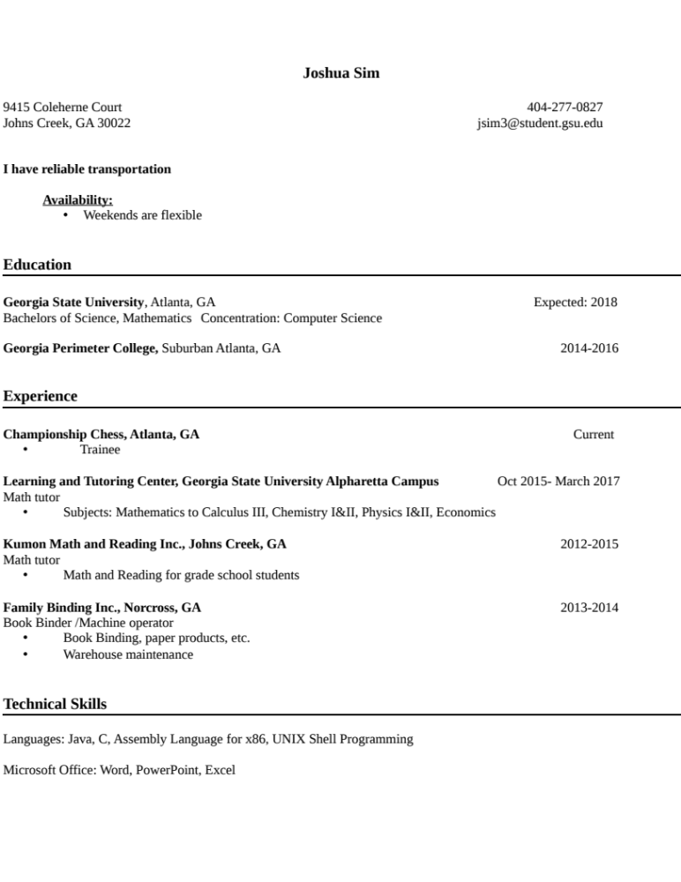

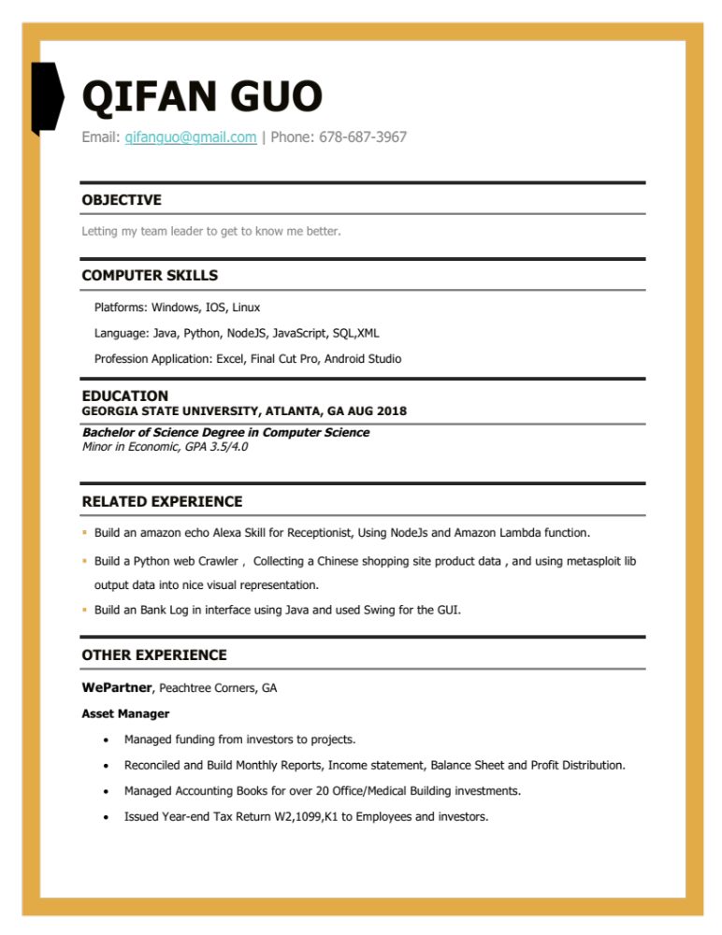
Dylan Monroe
17 Holly Downs Ct NW Atlanta, GA 30318
Cell: 770-403-0576
Email: DylanMonroe@me.com
https://www.linkedin.com/in/dylanmonroe/
Career:
Profile:
A highly proficient, skilled and knowledgeable computer science student with background in coding websites and computer and mobile applications. I am currently trying to pursue a job in Leadership within your company and have many strengths that I can bring along with being able to adhere to your knowledge and implement it correctly and efficiently.
Professional strengths:
- Possess excellent verbal and written communication skills
- Quick learner and ability to work under pressure
- Possess good management and organizational skills
- Ability to work in a team and under pressure
- Good motivator, enthusiastic and open to learn new ideas
- Sound knowledge of recognizing and analyzing information problems
- Ability to handle multiple tasks
Technical Proficiency:
- Programming Languages: JAVA,C, C++, Javascript,Assembly,Python,Ruby
- Operating systems: Windows
- Proficient in all office products
Professional Experience:
L.A Fitness Atlantic Station 03/2015-curent
- Worked almost every job in location

Jos A Bank Atlantic Station 03/2012-2015
- Highest Seller Multiple months
- Help manager’s when they were training
- Got a raise within the first 2 weeks

Personal Achievements:
- Graduated High School A year early and took on a extra course load
- Lived On my own and partially self-efficient at age 17
- Can Run off almost no sleep and be fine
Extra Curricular Activities:
- Help teach children how to golf
- Played High school golf and many tournaments around the U.S
- Help the homeless in many Food Kitchens
- Active member of Greening Forwards
Interest and Hobbies:
- Sports and Traveling
- Meeting people and shopping
- Playing Golf and Fitness
Educational Summary:
Mill Creek High School 3 Years(accelerated graduation)
Current Senior at Georgia State University
Personal Details:
- Name: Dylan Monroe
- Date of Birth: 07/21/1994
- Employment Status:Student
- Relationship status: Single
Thank you for the opportunity to introduce myself

Topic:
As a team, the project that we decided to do is to revamp Mr. Casturi’s school website. We chose this because we felt it was the most needed project that could be put into practical use and be completed successfully in the clients expected time span. We intend on updating the entire front end as well as adding a new home menu that will allow students to access different areas of the website which will be broken down to. It will help future students gain easier access to the materials that they are looking for like the syllabus, lectures, or homework assignments.
Work Share Document
Members Roles
Timothy Nguyen Project Manager
Dylan Monroe Project Support
Joshua Sim Project Support
Lee-Martin Clarke Project Support
Qifan Guo Project Support

